# image1

Report on highlights of the annual meeting – topics of discussion, decisions made, awards handed out, plans for the new year. Be sure to include thanks for the meeting planners!

# Annual Meeting News and Pics

CO-OP MONTHLY

Coop Motto Here Coop Motto Here

Co-op Calendar

**Oct. 1** Event 1

**Oct. 3** Event 2

**Oct. 17** Event 3



Happy Birthday

**Dec. 2** Mona Murphy

**Dec. 20** Mary Ryder

Happy Anniversary

**Dec. 5** Alice Burnes

**Dec. 20** Jim Murphy

Looking for Leaders!

Two of our current board members are planning to step down this year. Consider becoming a leader in your own business and joining the board. For more info about the obligations and satisfactions of the job, check in with Diane at DianeCares@gmail.com.



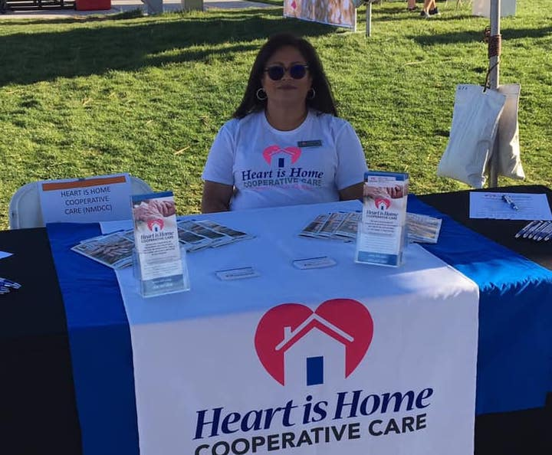

“By becoming a co-business owner with your fellow caregivers, you are going to develop business skills and abilities that you’ll be able to use in your personal life. It’s wonderful to see members become leaders.” --Margaret Bau, Wisconsin USDA Rural Development

The Co-op Difference

A co-op wide member satisfaction survey can give your board a sense of how providers are feeling about their work, their pay, and the support they feel from leadership and colleagues. Some questions to ask in your survey:

* Top things that work for you: flexibility, helping clients, an open and supportive office
* Top things you’d like to change: pay, health insurance, scheduling
* How likely are you to recommend working at the co-op to others?

Publish your survey results in your next issue, with follow up actions planned by the Board.

Survey Says! Tell us how you feel

Co-op Swag: Wear it Proud!

Encourage your members to wear and carry their co-op swag by inviting them to submit photos of them using/wearing their company gear. Offer a prize for the most creative photo.

Whose Pet Is It?

Invite co-op members to submit photos of their favorite pets. Challenge co-workers to guess who Fido belongs to. Winner gets a treat!

|  |  |
| --- | --- |
| **Report Ending:** | **Date** |
| **Caregiver Hours** |  |
| **Office Staff** |  |
| **Training and Ed.** |  |
| **Travel Time** |  |
| **Board Hours** |  |
| **Total Hours** |  |
| **OT** |  |
| **Holiday** |  |

*How Are We Doing?*

A look at our numbers this month.

|  |  |
| --- | --- |
| **New Hires** |  |
| **Employment Ended** |  |
| **Caregivers** |  |
| **Office Staff** |  |
| **RN** |  |

Staffing Report



*What the numbers mean for us…*

When our client list grows, our business grows, and so do our paychecks! By accepting 4 new clients last month, we were able to increase our caregiver hours from an average of 30 hours per week to 34. That’s more money in all of our pockets, just in time for the upcoming holiday season. The client bump also tells us that word is getting out in the community that HeartHomeCare is the best source around for quality care.

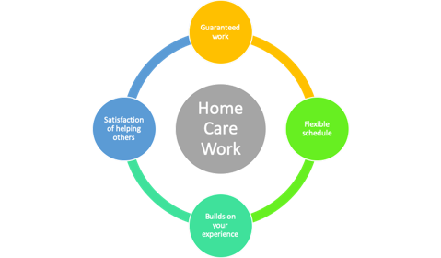

*How you can help.*

You are our best spokesperson for our business. Try to remember these persuasive facts when talking with friends and neighbors about the benefits of working in the fastest growing profession in the U.S.