# image1

CO-OP MONTHLY

Coop Motto Here Coop Motto Here

Co-op Calendar

**Oct. 1** Event 1

**Oct. 3** Event 2

**Oct. 17** Event 3



Happy Birthday

**Dec. 2** Mona Murphy

**Dec. 20** Mary Ryder

Happy Anniversary

**Dec. 5** Alice Burnes

**Dec. 20** Jim Murphy

Welcome New Board Members!

Martha Motzko, Administrative Director [Martha@Homecare.org](mailto:Martha@Homecare.org)

James McCarthy, Director of Membership

[James@Homecare.org](mailto:James@Homecare.org)



HeartHomeCare’s Executive Board will hold its annual meeting in January. Topics on the agenda:

* Planning the strategic direction of the co-op
* Building strategies for provider recruitment and retention
* Supporting and engaging co-op members

Do you have thoughts on these topics? Please share! The Board members would love to hear from you.

Report from the Executive Board

**Hooray for Technology!** Now you can log in to the office from your smartphone. Our new scheduling program allows remote access. All you need to do is download the app. Then open up your schedule to register your shift.

Any problems? Contact Martha by phone or email.

**Reminder: we have new office hours:**

We’ve adjusted our office hours for the

spring. The new schedule is as follows:

Mon/Wed/Friday: 9:00 a.m. – 5:00 p.m.

Tues/Thursday: 8:00 a.m. – 4:00 p.m.

# News From the Office

A look at our numbers this month.

*How Are We Doing?*

Member Spotlight.

Congratulations to Cathy Bataglia, who is celebrating her five-year anniversary with HeartHomeCare. Cathy became a member in 2014, after having cared for her ailing mother. “My experience with my mom was difficult, but it revealed something about me that I would not have known if I hadn’t needed to take care of her – I am a good caretaker and happy now to be in a profession I love.”



Recruitment Corner:

Promote your co-op’s incentive program for bringing in new caretakers here. One co-op’s Employee Referral Program offers up to $750 for each new hire recommended by a member. Referring members also get $250 when the new recruit reaches a 90 day milestone, and another $500 at the one year anniversary.

|  |  |
| --- | --- |
| **Report Ending:** | **Date** |
| **Caregiver Hours** |  |
| **Office Staff** |  |
| **Training and Ed.** |  |
| **Travel Time** |  |
| **Board Hours** |  |
| **Total Hours** |  |
| **OT** |  |
| **Holiday** |  |

Staffing Report

*What the numbers mean for us…*

|  |  |
| --- | --- |
| **New Hires** |  |
| **Employment Ended** |  |
| **Caregivers** |  |
| **Office Staff** |  |
| **RN** |  |

When our client list grows, our business grows, and so do our paychecks! By accepting 4 new clients last month, we were able to increase our caregiver hours from an average of 30 per week to 34. That’s more money in all of our pockets, just in time for the upcoming holiday season. The client bump also tells us that word is getting out in the community that HeartHomeCare is the source around for quality care.

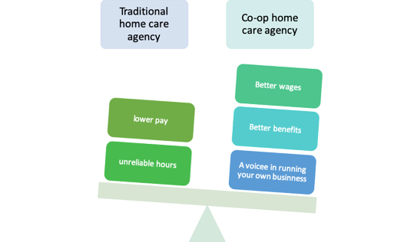

**Tell the Co-op Story** Home care co-ops retain more workers than traditional agencies do because co-op workers make more money, have more reliable hours, and are happier on the job. Use the info in this graphic to tell our story.